Frida Kahlo Is a Barbie Doll Now. (Signature Unibrow Not Included.)
The Inspiring Women series’ Frida Kahlo Barbie doll from Mattel, left, and the Mexican artist, circa 1950.CreditFrom left: Barbie, via Associated Press; Getty Images

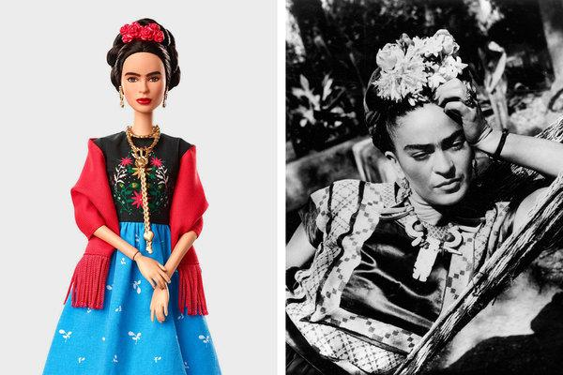

The Inspiring Women series’ Frida Kahlo Barbie doll from Mattel, left, and the Mexican artist, circa 1950.CreditCreditFrom left: Barbie, via Associated Press; Getty Images

By Colin Moynihan
- March 9, 2018

  - Over the years the name and likeness of the Mexican artist Frida Kahlo, a fierce feminist and ardent communist, have been associated with a number of unlikely products.
Sneakers. Lipstick. Beer.
But Barbie doll?
Yes, Mattel, which manufactures Barbie, included a Kahlo doll in an inaugural series meant to coincide with International Women’s Day.
She is part of the line of “Inspiring Women” dolls that includes the aviator Amelia Earhart and the NASA mathematician Katherine Johnson, whose life was featured in the movie “Hidden Figures.”
Kahlo, whom Mattel described as “a celebrated artist, activist and symbol of strength” and who died at the age of 47 in 1954, was known for self-portraits and other works that the Surrealist leader André Breton described as “a ribbon around a bomb.” She may not have approved of being cast as a variety of Barbie, the best-selling doll whose image Mattel has updated so as to address criticism that in body type and lifestyle it had perpetuated damaging stereotypes about women.
ADVERTISEMENT
Certainly one family member took exception to Mattel’s depiction of the artist, which eliminated her signature unibrow, a long single eyebrow that one commentator found emblematic of “her striking and beautiful refusal to give in to certain sexist societal pressures.”
“I would have liked the doll to have traits more like Frida’s, not this doll with light-colored eyes,” Mara Romeo, who said she was Kahlo’s great-niece, told Agence France-Presse. “It should be a doll that represents everything my aunt represented, her strength.”
A lawyer for Ms. Romeo added that Mattel did not have the rights to use Kahlo’s image, according to the news agency.
Mattel said in a statement that it had “secured permission and worked in close partnership with the Frida Kahlo Corporation, the owner of all rights related to Frida Kahlo, to make this doll.”
Beatriz Alvarado, a spokeswoman for the Frida Kahlo Corporation, said by telephone on Friday that the company had been formed by people who secured rights to market Kahlo’s name and likeness after paying a fee in 2005 to Isolda Pineda Kahlo, one of the artist’s nieces.

