Frida Kahlo Was a Painter, a Brand Builder, a Survivor. And So Much More.
The artist and pop culture icon meticulously built her own image. A sweeping survey at the Brooklyn Museum examines how she did it, and why.

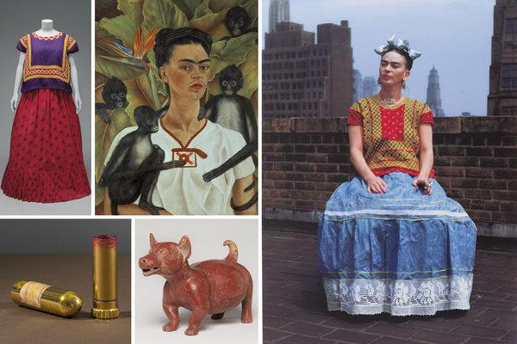

Scenes from “Frida Kahlo: Appearances Can Be Deceiving” at the Brooklyn Museum. Credit, Clockwise from top left, Diego Rivera and Frida Kahlo Archives, Banco de México, Fiduciary of the Trust of the Diego Rivera and Frida Kahlo Museums; Javier Hinojosa, via V&A Publishing (dress and lipstick); Banco de México Diego Rivera Frida Kahlo Museums Trust, Mexico, D.F./Artists Rights Society (ARS), New York; The Jacques and Natasha Gelman Collection of 20 Century Mexican Art and the Vergel Foundation; Nickolas Muray Photo Archive; Brooklyn Museum; Brooklyn Museum

By Rebecca Kleinman
Jan. 31, 2019

Frida Kahlo’s exhaustively documented crossover from artist to pop culture icon isn’t happenstance. The painter meticulously crafted her own image on a par with Cleopatra. If she were alive today, she’d probably be teaching a branding class at Harvard. Now it’s America’s turn to see how, and, more important, why she did it.

Some of the contents of the home she shared with her husband, the muralist Diego Rivera — known as La Casa Azul (Blue House) in Mexico City — will be accessible for the first time in the United States in “Frida Kahlo: Appearances Can Be Deceiving,” an exhibition at the Brooklyn Museum, from Feb. 8 to May 12. Their belongings were to be locked away until 15 years after Rivera’s death, according to his instructions, but the task of unsealing and inventorying them didn’t happen until much later, in 2004. This is the biggest stateside show devoted to Kahlo and a considerably expanded iteration of last year’s exhibition at the Victoria and Albert Museum in London.

The sweeping survey adds greater insight into Kahlo’s collecting habits through works culled from the museum’s vault as well as the New York chapter of her timeline, and includes works lent by local institutions and galleries. The supplementary mix of Mesoamerican objects, one of the many types of art the couple favored, with her paintings and photographs divulge her yearning for Mexico’s indigenous and agrarian culture and her conflicts with capitalism, especially in the income inequality she witnessed during her travels in the United States.
Visitors will better understand Kahlo’s skill in searing her likeness into the public imagination, even if it meant dangling monkeys around her head and cultivating her most recognizable physical traits — a statement ’stache and unibrow. Neither her disabilities from polio and a bus accident, nor her frequent relapses of pain deterred Kahlo. By the time she died at the age of 47 in 1954, she left behind a public persona that is still being mined well into the 21st century; today she has more than 800,000 Instagram followers.

“People have an insatiable curiosity with her, and this presentation is a rare opportunity to see how she built her identity,” said Catherine Morris, a senior curator at the Elizabeth A. Sackler Center for Feminist Art, who organized the Brooklyn Museum’s version of the show with Lisa Small, senior curator of European Art. Here, they share some of their insights.
Beauty Routine

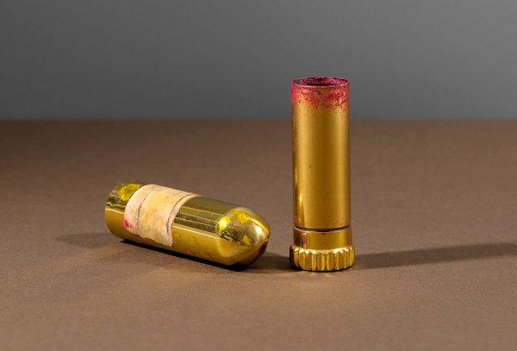

The exhibition includes her daily beauty products such as Revlon’s “Everything’s Rosy” lipstick, 1944-54.CreditDiego Rivera and Frida Kahlo Archives, Banco de México, Fiduciary of the Trust of the Diego Rivera and Frida Kahlo Museums; Javier Hinojosa, via V&a Publishing
Viewing Kahlo’s beauty products brings to mind a child’s sense of wonder with a mother’s dressing table. “There’s an aura in the presence of her actual things that you just can’t experience through media and Instagram,” Ms. Morris said of Kahlo’s eyebrow pencil, Pond’s Dry Face Cream, and red lipstick and vibrant nail polishes from Revlon, a favorite brand. “If you look at her images, she always had a perfect manicure.” Ms. Small pointed out that Kahlo “carefully groomed her unibrow,” a defiant choice at a time when “many depilatory methods existed. That brow was meaningful because it didn’t conform to Hollywood beauty standards.”

Tehuana Transformation

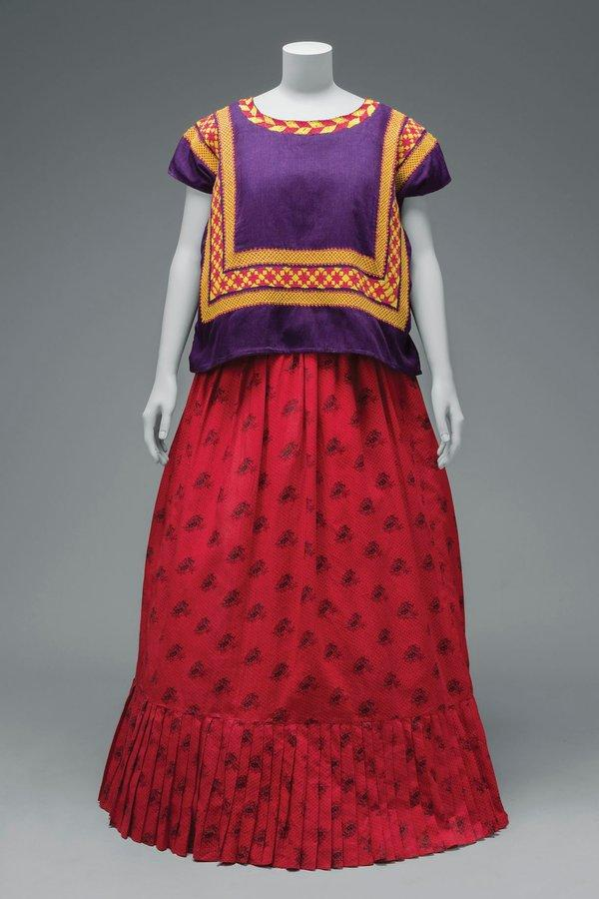

Cotton huipil with chain-stitch embroidery; cotton skirt with printed floral motifs.CreditDiego Rivera and Frida Kahlo Archives, Banco de México, Fiduciary of the Trust of the Diego Rivera and Frida Kahlo Museums; Javier Hinojosa, via V&A Publishing
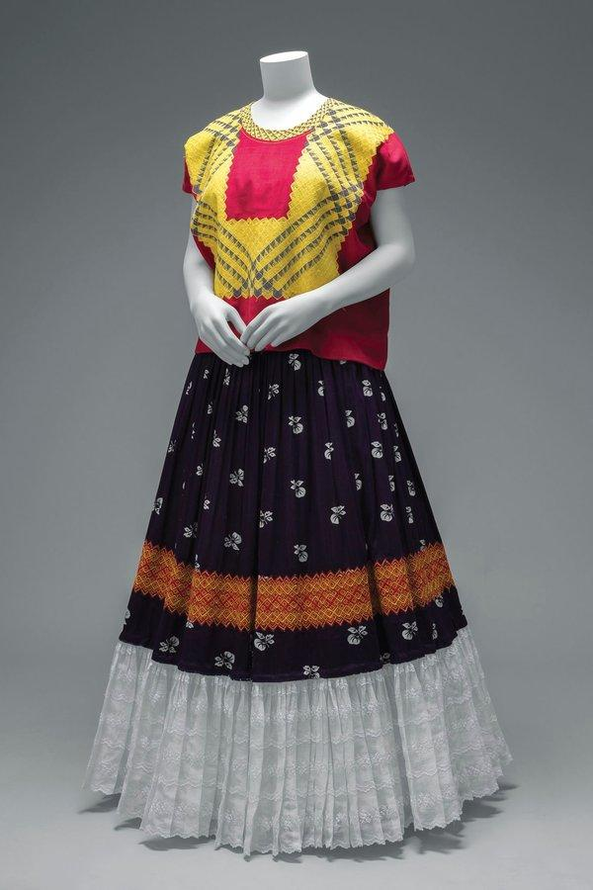

Cotton huipil with machine-embroidered chain stitch; printed cotton skirt with embroidery.CreditDiego Rivera and Frida Kahlo Archives, Banco de México, Fiduciary of the Trust of the Diego Rivera and Frida Kahlo Museums; Javier Hinojosa, via V&A Publishing

A mastermind at using fashion to her advantage, Kahlo delivered red-carpet moments wherever she went. “She even dressed that way to work in her studio,” Ms. Small said. Her ethnic ensembles, famously inspired by Oaxaca’s Tehuana, a matriarchal society, dismissed de rigueur looks dictated by Parisian designers and the soulless mass production of clothing. Vogue magazine took notice. Kahlo championed her homeland’s indigenous customs in wearing huipiles (woven tunics), rebozos (shawls) and flouncy, long skirts. They also drew attention away from her polio-ravaged right leg and body casts from several operations after her near-fatal bus accident. She frequently referred to herself as the great concealer.
The Body As Canvas

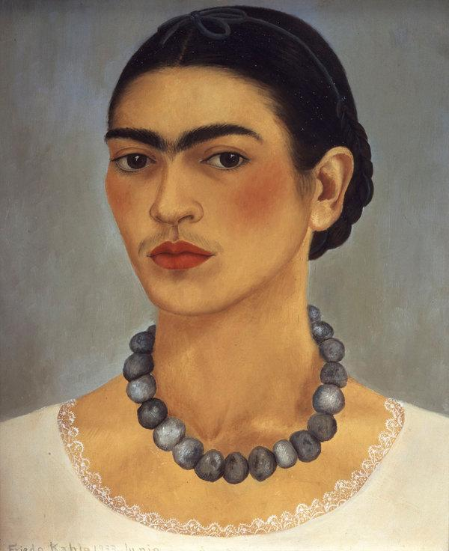

Frida Kahlo, “Self-Portrait With a Necklace,” 1933, oil on metal. Jade stones in the show are Mesoamerican, from her personal collection.CreditBanco de México Diego Rivera Frida Kahlo Museums Trust, Mexico, D.F./Artists Rights Society (ARS), New York; The Jacques and Natasha Gelman Collection of 20th Century Mexican Art and the Vergel Foundation
Besides its feminine allure, jewelry struck a more personal chord for Kahlo. Like her intricate updos embellished with hair ornaments and blossoms, chandelier earrings and bold necklaces drew onlookers’ focus to her face. They were also another vehicle for her to express her passion for Mexican crafts including contemporary silver jewelry and native materials like jade, favored by the ancient Maya. “She most commonly wore gold rope necklaces and Mesoamerican jade stones, which she’d string into extraordinarily chunky necklaces,” Ms. Small said.

A Microcosm of Mexico

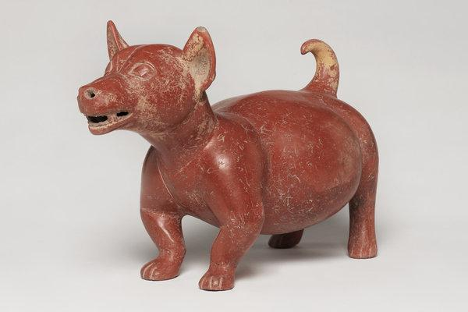
A Colima dog figure, 200 B.C.E.-500 C.E., ceramic, evokes the spirit of the collections at La Casa Azul.CreditBrooklyn Museum

In one gallery, the curators set out to re-create the vibe of Kahlo and Rivera’s home. Azure-painted walls and a case of Mesoamerican ceramic and stone sculptures and vessels, from the Brooklyn Museum’s permanent collection, evoke its spirit. The ancient objects convey the couple’s eclectic taste and deep appreciation for Mexican art and archaeology. “They’d have a colonial portrait next to a pre-Columbian piece next to a gas mask from the 1940s,” said Ms. Small, who located a Colima dog sculpture in the museum’s collection similar to those at La Casa Azul.

Mother of a Mini-Menagerie

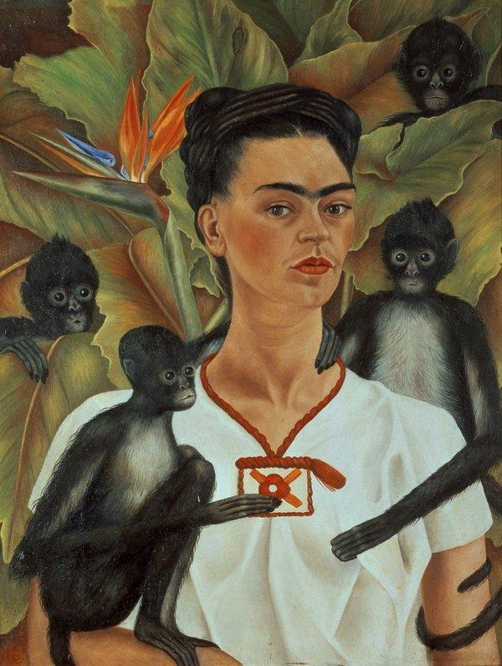
“Self-Portrait With Monkeys,” 1943, oil on canvas.CreditBanco de México Diego Rivera Frida Kahlo Museums Trust, Mexico, D.F./Artists Rights Society (ARS), New York; The Jacques and Natasha Gelman Collection of 20 Century Mexican Art and the Vergel Foundation

Animals graced her work, and she had a mini-menagerie at La Casa Azul. There was a chaotic array of dogs — she adored the hairless variety of Xoloitzcuintli, an ancient breed — as well as monkeys, exotic birds and a deer named Granizo roaming about (which must have been a wild trip for guests).

New York Chapter

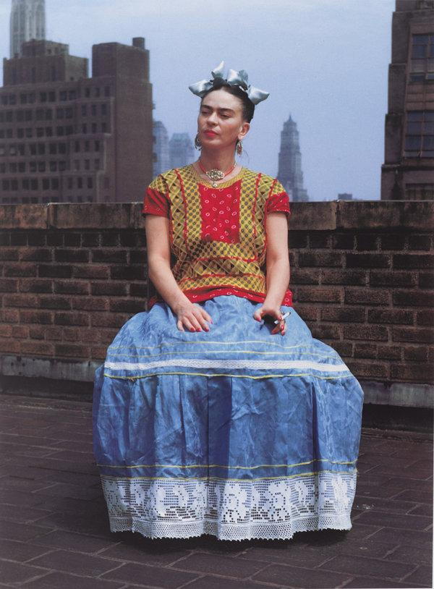

“Frida in New York” by Nickolas Muray, 1946, printed 2006, carbon pigment print. Credit Nickolas Muray Photo Archive; Brooklyn Museum

Kahlo and Rivera traveled through the United States from 1930 through 1934, spending time in San Francisco, Detroit and New York City, where Rivera received major mural commissions. As a tourist and Communist, Kahlo was both dazzled and disgusted by New York City. “She loved going to the movies in New York, but its great disparities of wealth were eye-opening,” Ms. Small said. Kahlo owed a bump in her career and stardom to her New York connections. The gallerist Julien Levy granted Kahlo her first and only New York show during her lifetime in 1938, while the photographer Nickolas Muray captured the juxtaposition of her ethnic dress and the modern metropolis in 1946. A Vogue spread promoted her from the wife of an artist to Rivera’s rival.

Gender Role Play

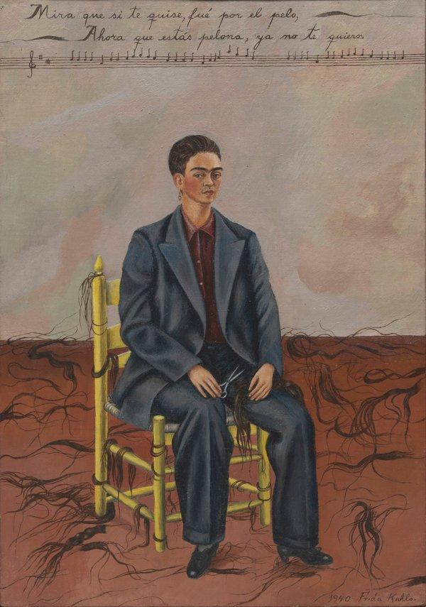

“Self-Portrait With Cropped Hair,” 1940, oil on canvas.CreditBanco de México Diego Rivera Frida Kahlo Museums Trust, Mexico, D.F./Artists Rights Society (ARS), New York; The Museum of Modern Art/Licensed by SCALA/Art Resource, NY
Comfort with cross-dressing came early on. In a family portrait, by her father, the photographer Guillermo Kahlo, a teenage Kahlo wears a suit and parts and tucks her hair like a natty chap. Emmy Lou Packard’s 1941 photograph shows Kahlo in cuffed dungarees, smoking a cigarette. For “Self-Portrait With Cropped Hair,” in 1940, with scissors and musical notes, she returns to men’s wear with a baggy suit like those worn by her ex-husband. (They had recently divorced.) Shorn in spite, her cropped cut re-establishes her independence. “People are very interested in the fact that she had relationships with women, but there’s only one known reference where she actually spoke about it,” Ms. Morris said.

Transforming Pain into Art

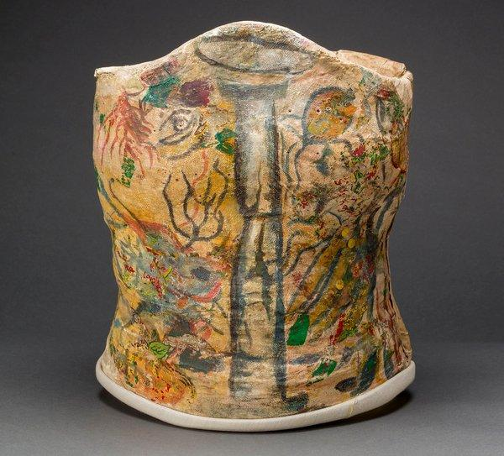
A plaster corset, painted and decorated by Frida Kahlo, from Museo Frida Kahlo. CreditDiego Rivera and Frida Kahlo Archives, Banco de México, Fiduciary of the Trust of the Diego Rivera and Frida Kahlo Museums; Javier Hinojosa, via V&A Publishing
Kahlo suffered extensively for much of her life, and the most moving section of the show is devoted to her ecosystem of medical devices. But Kahlo did not conceal her pain, revealing her casts and leather braces with metal buckles in her work and turning her plaster corsets into art with elaborate designs of flowers, even a hammer and sickle. “She treated these second skins as canvases,” Ms. Small said.

Kahlo’s right leg was amputated the year before she died in 1954. (The official cause of death was pulmonary embolism.) “She’s often portrayed as a victim, and we’re consciously trying to reframe her,” Ms. Morris said. “People have described her as broken and fragile, but she was strong and accomplished a tremendous amount in her lifetime.”

