OLLI at Duke Fall 2015
Kris Door, lecturer kristinedoor.com
North Carolina Museum of Art Lectures Tuesdays 11:00-12:30
Da Vinci and Escher; the Science of Art
Lecture 3 November 10: Perspective, Distortion, Metamorphosis
SLIDE LIST

History of Perspective
- Fresco wall painting in a cubiculum (bedroom) from the Villa of P. Fannius Synistor at Boscoreale, c. 40–30 B.C. Metropolitan Museum of Art
- Roman frescos from Boscoreale, 43–30 B C Metropolitan Museum of Art
- Circle of the Berlinghieri Family, Madonna and Child, 1230–1240, tempera and gold
leaf on panel NCMA
- Giotto di Bondone, Legend of St Joachim, Meeting at the Golden Gate, 1305 Arena Chapel
- Baptistery of Florence
- Competition panels 1401: Brunelleschi's Sacrifice Ghiberti's Sacrifice
- Pantheon, Rome
- Brunelleschi perspective system, c.1413
- Masaccio, Tribute Money, c.1426–1428, fresco, Brancacci Chapel, Santa Maria del Carmine, Florence
- Masaccio, Trinità, 1427 fresco, Santa Maria Novella, Florence
- Alberti, The Art of Painting, 1435
a simple 1-point perspective system based upon a unit 1/3 times the height of a human
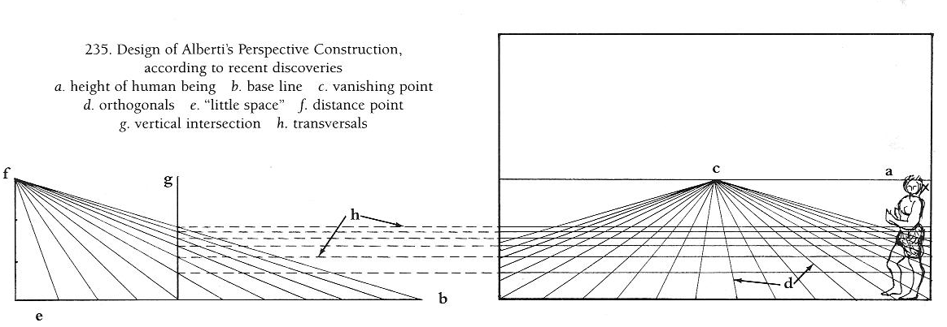

"picture window" of Renaissance vision--through perspective (linear and atmospheric) and chiaroscuro (shading)
- Lorenzo Ghiberti, Jacob & Esau, Panel for Gates of Paradise, 1425–52
gilt bronze Museo dell’Opera del Duomo, Florence
- Leonardo da Vinci, Last Supper, 1494-1498, tempera on gesso, pitch and mastic, Santa Maria delle Grazie, Milan
- Raphael, School of Athens (Philosophy) 1510-1511, Vatican Apartments, Rome

Foreshortening
- Andrea Mantegna, The Lamentation over the Dead Christ, c. 1480 tempera on canvas
Pinacoteca di Brera, Milan
  - Camera degli Sposi, ceiling, 1465-74, Ducal Palace, Mantua
- Leonardo Da Vinci, The Virgin of the Rocks, Louvre version, c.1483-86
- M.C. Escher, Self Portrait in a Chair, 1920 Woodcut.

Northern Renaissance Perspective
- Master of the Latour d'Auvergne Triptych, The Annunciation, c.1497 oil on panel NCMA
- Albrecht Durer, Draughtsman Drawing a Recumbent Woman, 1525 Woodcut
- Albrecht Durer, Draughtsman Drawing a Lute, 1525 Engraving

Perspective and foreshortening as symbol
- Filippino Lippi, Madonna and Child in Majesty with Saints, c. 1478- 86, Uffizi
- Bernardino Lanino, Madonna & Child Enthroned with Saints and Donors, 1552 Oil
on panel NCMA

Perspective manipulated; Mannerism and Baroque
- Titian, Pesaro Madonna, 1519–15 Oil on canvas, Santa Maria Gloriosa dei Frari, Venice
- Tintoretto, The Last Supper, 1592-94, Oil on canvas San Giorgia Maggiore, Venice
- Domenico Tintoretto, Italian, The Rising of Lazarus, 1585-90, Oil on Canvas NCMA
- Jaume Plensa, Together and Mist (2014) Installation view San Giorgio Maggiore (2015)
- Andrea Pozzo, painted ceiling in the Church of St. Ignazio, Rome 1685-94

Anamorphosis
- Leonardo da Vinci, Anamorphosis, study of eye, with juvenile face, Codex Atlanticus,
- Hans Holbein the Younger, The Ambasadors,1533, Oil on oak, National Gallery, London
- Example of mirror anamorphosis
- Plane anamorphosis by Jean Francois Niceron, 1638.
- M.C. Escher, Balcony, lithograph, 1945
- Carel Fabritius, View of Deft, 1652, Oil on canvas National Gallery, London
- Samuel Dirksz van Hoogstraten, View of a Corridor, Dyrham Park, 1662
- Pieter de Hooch, The Fireside, c. 1670-1675, oil on canvas NCMA
- Samuel Dirksz van Hoogstraten, A Peepshow with Views of the Interior of a Dutch House, 1655-60 National Gallery, London

Reflection as a Theme
- Jan van Eyck, Portrait of Giovanni Arnolfini & his Wife, 1434 oil on oak, National Gallery, London
- Parmigianino, Self-portrait in a Convex Mirror, c. 1523–1524, Kunsthistorisches Museum, Vienna
- M.C. Escher, Hand with Reflecting Sphere, 1935, lithograph.
- Pieter Claesz, Vanitas Still Life with Self-Portrait, 1628 National Museum, Nuremberg
- Jacques de Gheyn II, Vanitas Still Life, 1603 oil on wood Metropolitan Museum
- M.C. Escher, Eye, 1946 mezzotint, 7th and final stage

Metamorphosis
- M.C. Escher, Sky and Water I, 1938 woodcut.
- Giuseppe Arcimboldo, The Four Seasons, oil on canvas Louvre
- Ralph Helmick, Stuart Schechter, Rample, 2003 NCMA
- Bernini, Apollo and Daphne, c. 1622 Borghese Gallery, Rome

