The Real Story Behind Frida Kahlo’s Style
A new exhibition at the Victoria and Albert Museum in London explores how the artist’s physical disabilities influenced her well-known image.
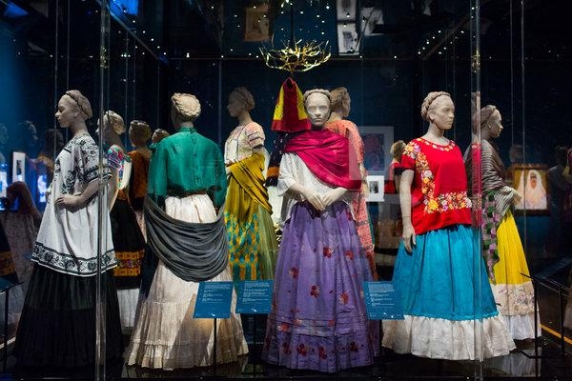

A display of clothes belonging to the artist Frida Kahlo, part of the exhibition “Frida Kahlo: Making Her Self Up,” which opens Saturday at the Victoria.
Credit Lauren Fleishman for The New York Times

By Hettie Judah
- June 15, 2018

LONDON — In late May, the high-ceiling textile-conservation department of the Victoria and Albert Museum was buzzing with activity. Curators fitted several full enagua skirts and square-cut embroidered huipil blouses — some bearing traces of paint and ink — onto mannequins. Alongside were heavy strings of Aztec beads, richly colored rebozo shawls and a starched lace headdress known as a resplandor — all ingredients of what would become the museum’s major summer exhibition: “Frida Kahlo: Making Her Self Up.”
Scheduled to open on Saturday and run to Nov. 4, the show is the latest manifestation of a vogue for examining an artist’s image as a creation in its own right. Last year, the Brooklyn Museum exhibited Georgia O’Keeffe’s androgynous, understated attire; and a show of artworks by Gluck at the Brighton Museum in England included examples of the British artist's mannish 1920s tailoring.

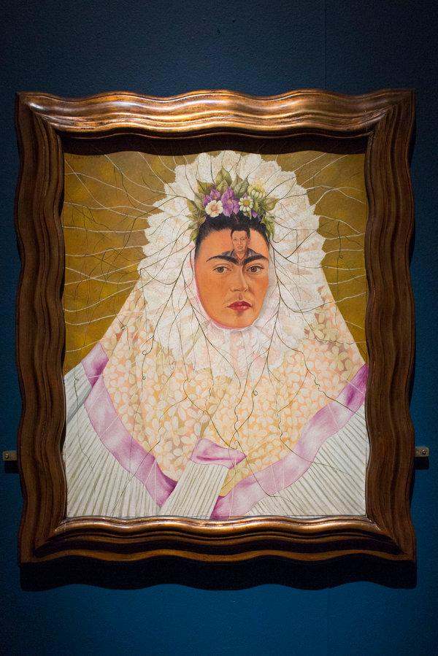
Ms. Kahlo’s “Self-Portrait as a Tehuana” (1943).
CreditLauren Fleishman for The New York Times
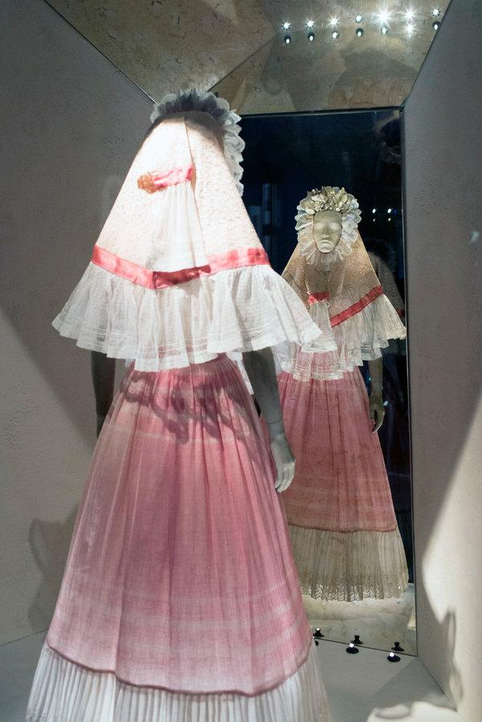

A resplandor, a typical headdress of the Tehuana women in the province of Oaxaca, Mexico. It is made with white lace and satin ribbons.
Credit Lauren Fleishman for The New York Times
But “Making Her Self Up,” which includes drawings and paintings, as well as choice items from Ms. Kahlo’s wardrobe, will bring added edge to this approach thanks to the pop culture embrace of the artist’s appearance, and the exhibition’s attempt to tell a new story about what, exactly, lay behind her look: a desire to accommodate and distract from her physical disabilities.
The Kahlo likeness — reduced to a shorthand of flower-studded braids, unibrow, rosy lips and bright blouse — gazes today from products including socks and yoga pants. Her style informs magazine fashion shoots, retail displays and even a Barbie doll. Yet in none of these representations does Ms. Kahlo appear as anything other than an able-bodied woman.
At age 6, Ms. Kahlo had polio, which left her right leg shorter than her left. She was teased at school for her withered leg and limp, said Circe Henestrosa, co-curator of the exhibition, and her dress became a way to conceal it. “She’d wear three or four socks to level her legs, and started to wear long skirts,” Ms. Henestrosa said.
Then, when she was 18, a school bus carrying Ms. Kahlo collided with a tram, and her body “was pierced through to the pelvic bone,” the curator said. She suffered more than 20 bone fractures, most to the spine.
“To recover, she spent about a year in bed,” Ms. Henestrosa said. “This is the beginning of the art, and of the deterioration of her body.”
Over her lifetime, Ms. Kahlo had more than 30 operations, including, in 1953, the amputation of her right leg. She died the next year, at age 47.
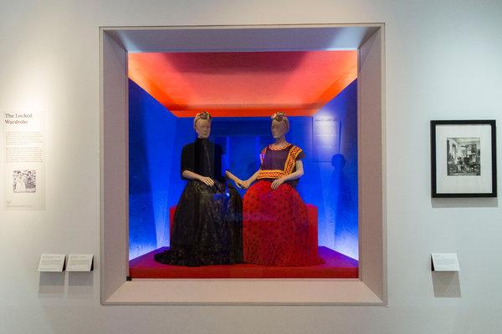

Two of Ms. Kahlo's outfits on display in London. On the left, a cape and skirt in silk, velvet satin and lace from the early 1900s, and right, a Tehuana cotton outfit from before 1954. CreditLauren Fleishman for The New York Times

In her 20s, Ms. Kahlo started wearing her own interpretation of traditional Tehuana dress: full skirts, embroidered blouses and regal coiffure associated with a matriarchal society from the Isthmus of Tehuantepec in Oaxaca, Mexico. Seen as a proud assertion of her national identity, Ms. Henestrosa and her fellow curator, Claire Wilcox, suggest that the artist’s distinctive dress served a double purpose: effectively concealing her body and focusing attention on her head and shoulders. “The last thing you’d be thinking of when you saw her were her disabilities,” Ms. Wilcox said. “The flamboyance was distracting.”
ADVERTISEMENT
The boxy huipil blouses were made without fastenings, and could drop loosely over a back brace or plaster cast. Their short length was well suited to working while seated, whether in a chair, bed or wheelchair. The long flowing skirts covered her wasted leg, and their motion helped conceal her limp.
Ms. Kahlo's jewelry included torzales, long woven chains of gold, and pendant necklaces.CreditLauren Fleishman for The New York Times
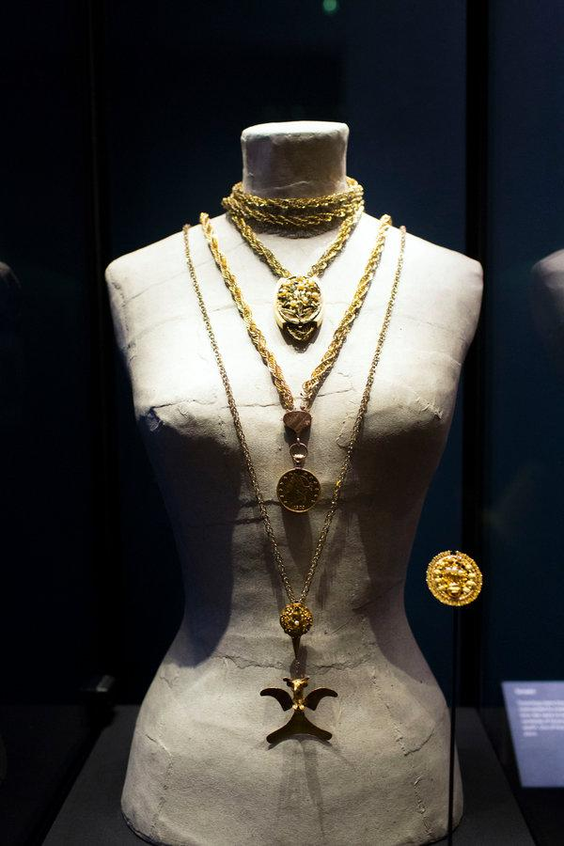

Ms. Kahlo's jewelry included torzales, long woven chains of gold, and pendant necklaces.
CreditLauren Fleishman for The New York Times
Ms. Kahlo took great pleasure in her dress, and enjoyed the sensation that she caused when visiting San Francisco in 1930. The show notes include the artist’s excited letter to her mother: “The gringas really like me a lot and pay close attention to all the dresses and rebozos that I brought with me, their jaws drop at the sight of my jade necklaces.”
In San Francisco, she bought Chinese cloth and embroidery panels that were integrated in her wardrobe, alongside Guatemalan sashes and coats. Frilled shirts, heavy necklaces of jade and coral, and pinned flowers all directed attention where she wished it to fall: “The adornment is concentrated from the torso up,” Ms. Henestrosa said. “The beautiful headdresses and jewelry distracted you from her legs and her body.”
The 22 outfits that will be on show are among those discovered in 2004 at the Casa Azul, Ms. Kahlo’s home in Coyoacán, Mexico. They had been stored for almost half a century after the death of her husband, the muralist Diego Rivera, along with 6,500 photographs (among them works by Edward Weston, Tina Modotti, Man Ray and Nickolas Muray, Ms. Kahlo’s lover), as well as drawings, letters, documents and personal possessions.

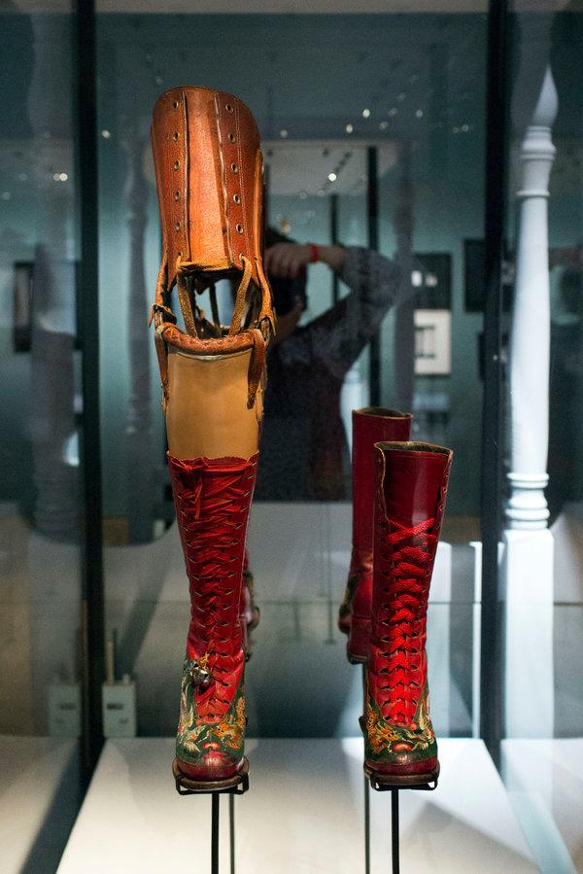

A pair of Ms. Kahlo’s boots, with wedge heels. One has a prosthetic leg attached.
CreditLauren Fleishman for The New York Times
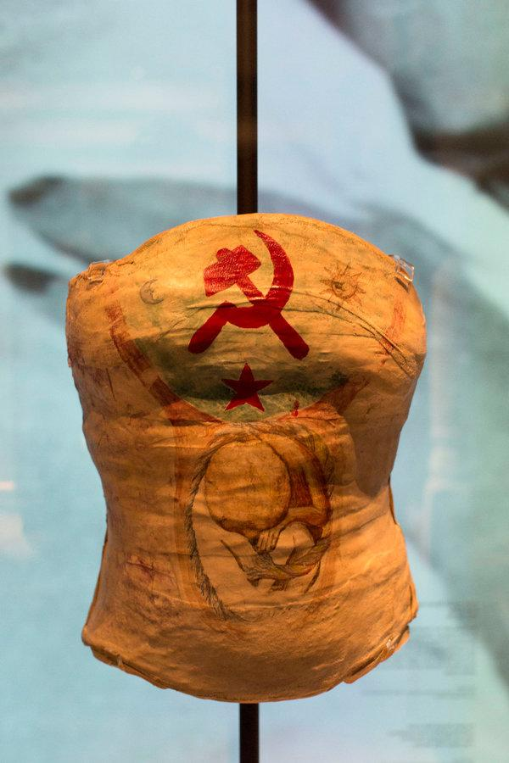
A plaster corset decorated by Ms. Kahlo.CreditLauren Fleishman for The New York Tim
In the exhibition are back braces, reinforced with metal bars and covered in leather; three medical plaster casts that had been cut off Ms. Kahlo’s torso; a pair of handmade boots, decorated with Chinese embroidery and with a built-up sole for the right foot; and a prosthetic leg, sculpted by the artist and dressed with an embroidered red leather boot, bells and ribbons.
Found at the back of a wardrobe was a self portrait in charcoal and crayon, now part of the display, that showed Ms. Kahlo’s broken body — a shattered Grecian column for a spine, a medical corset strapped tight around her torso, her right leg wasted — exposed beneath transparent dress. Along the bottom is written, in Spanish, “Appearances can be Deceiving.”

“She masked her disability in dress, but not in her art,” Ms. Henestrosa said. “There it was very boldly displayed.”

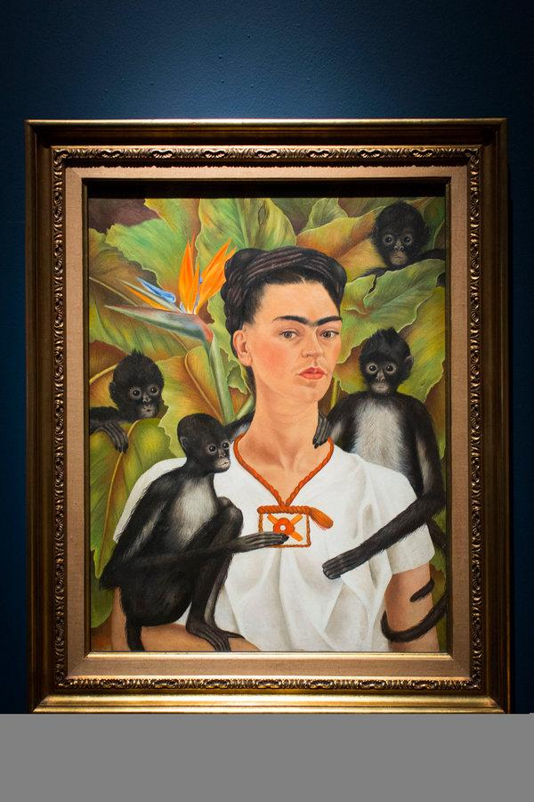

“Self Portrait With Monkeys” (1943).
CreditLauren Fleishman for The New York Times
Clothes for disabled women tend to be promoted in terms of functionality, said Eleanor Lisney, a founding member of the disabled women’s collective Sisters of Frida, which is based in Britain. But, she added, “What we wear is part of us: That has to reflect the fashion that’s going on around us, we don’t want to be left out.” Thanks to the work of activists such as Sinéad Burke, the 3.5-foot-tall Irish woman who describes herself as a “little person” and who has been lobbying for fashion-world recognition of diversity, things are starting to shift.
Ms. Kahlo “didn’t allow her disability to define her, but it was an integral part of her life,” Ms. Wilcox said. The gorgeous, jewel-bedecked image that the artist constructed for herself wouldn’t have been the same without it.

